LAB Manual

PART A

(PART A : TO BE REFFERED BY STUDENTS)

**Experiment No.08**

PART B

(PART B : TO BE COMPLETED BY STUDENTS)

***(Students must submit the soft copy as per following segments within two hours of the practical. The soft copy must be uploaded on the Blackboard or emailed to the concerned lab in charge faculties at the end of the practical in case the there is no Black board access available)***

| Roll No.: C026 | Name: Anirbaan |
| --- | --- |
| Class : B | Batch : EB1 |
| Date of Experiment: 11/10/2023 | Date of Submission 11/10/2023 |
| Grade : | Time of Submission: |
| Date of Grading: |  |

**B.1 Software Code written by student:**

***(Paste your Matlab code completed during the 2 hours of practical in the lab here)***

***#Name: Anirbaan Ghatak***

***#Roll no.: C026***

***#Aim: Write a program to apply morphological operations on an image.***

***import cv2***

***import numpy as np***

***import matplotlib.pyplot as plt***

***gray_img = cv2.imread('IMG_2458_grey_CLOSEUP.jpg', cv2.IMREAD_GRAYSCALE)***

***# Convert the grayscale image to binary image***

***_, binary_img = cv2.threshold(gray_img, 128, 255, cv2.THRESH_BINARY)***

***# Save the binary image***

***img = binary_img***

***# Define the kernel for morphological operations***

***kernel = np.ones((5, 5), np.uint8)***

***# Erosion***

***erosion = cv2.erode(img, kernel, iterations=1)***

***# Dilation***

***dilation = cv2.dilate(img, kernel, iterations=1)***

***# Opening***

***opening = cv2.morphologyEx(img, cv2.MORPH_OPEN, kernel)***

***# Closing***

***closing = cv2.morphologyEx(img, cv2.MORPH_CLOSE, kernel)***

***plt.figure(figsize=(20, 16))***

***# Plot the first image in the top left position***

***plt.subplot(2, 3, 1)***

***plt.imshow(img, cmap='gray')***

***plt.title('Original')***

***plt.axis('off')***

***# Plot the second image in the top right position***

***plt.subplot(2, 3, 2)***

***plt.imshow(erosion, cmap='gray')***

***plt.title('Erosion')***

***plt.axis('off')***

***# Plot the third image in the bottom left position***

***plt.subplot(2, 3, 3)***

***plt.imshow(dilation, cmap='gray')***

***plt.title('Dialation')***

***plt.axis('off')***

***# Plot the fourth image in the bottom right position***

***plt.subplot(2, 3, 4)***

***plt.imshow(opening, cmap='gray')***

***plt.title('Opening')***

***plt.axis('off')***

***plt.subplot(2, 3, 5)***

***plt.imshow(closing, cmap='gray')***

***plt.title('Closing')***

***plt.axis('off')***

***plt.tight_layout()***

***plt.show()***

**B.2 Input and Output:**

***(Paste your program input and output in following format, If there is error then paste the specific error in the output part. In case of error with due permission of the faculty extension can be given to submit the error free code with output in due course of time. Students will be graded accordingly.)***

**Input Images:**

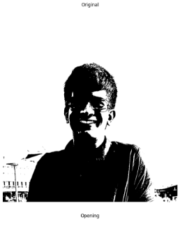

**Output Images:**

1. **For each morphological operation discussed in section A.5.**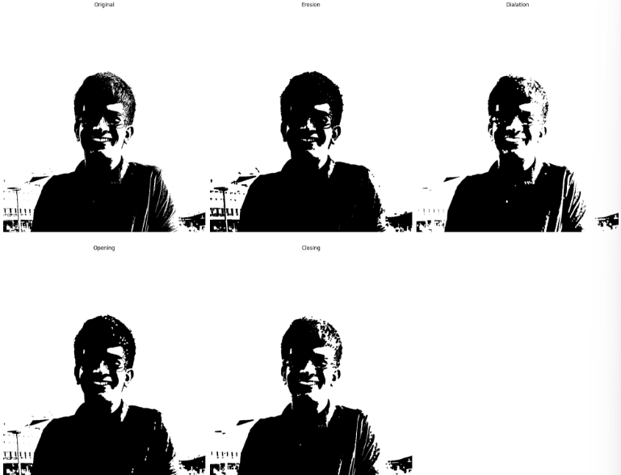

**B.3 Observations and Learning:**

***Morphological operations (erosion, dilation, opening, closing) are applied to a binary image. Erosion shrinks white regions, useful for isolating structures and reducing noise. Dilation enlarges white regions, aiding in closing gaps and enhancing structure boundaries. Opening combines erosion and dilation, effective in noise removal and small object elimination. Closing, a dilation followed by erosion, proves useful in closing small gaps within the binary image, showcasing the fundamental role of morphological operations in image enhancement and preprocessing.***

**B.4 Conclusion:**

*Applied Morphological operations such as erosion dilation opening and closing on the input images and gathered knowledge about how each one of them affects the input image.*

**B.5 Question of Curiosity**

**1. What output you expect if the morphological operations are applied to a grey scale image?**

Morphological operations can also be applied to grayscale images, typically using structuring elements or kernels that are grayscale themselves. The primary morphological operations for grayscale images are erosion and dilation. Here's what you can expect when these operations are applied to a grayscale image:

Erosion:

Erosion in grayscale images involves moving a structuring element over the image and replacing each pixel's value with the minimum value of the pixels covered by the structuring element. This has the effect of "eroding" the brighter regions in the image, making dark regions grow.

Dilation:

Dilation in grayscale images involves replacing each pixel's value with the maximum value of the pixels covered by the structuring element. This has the effect of "dilating" the brighter regions in the image, making them grow.

These operations can be useful in various image processing applications, such as noise reduction, edge detection, and segmentation. The specific impact on the image will depend on the size and shape of the structuring element, as well as the characteristics of the grayscale image itself.

**2. What are the different real life applications of morphological operations? Explain any one in detail.**

Real-life application of morphological operations is in medical image analysis, particularly in the domain of medical imaging. Morphological operations play a crucial role in image preprocessing and enhancement, aiding in the extraction of meaningful information from medical images such as X-rays, CT scans, and MRI images. For instance, in the context of tumor detection and analysis, morphological operations are used to enhance and segment regions of interest within medical images. Erosion can help to isolate tumor boundaries by gradually eroding the background, and dilation can help in filling gaps within the tumor regions for a more accurate segmentation.

In detail, consider a scenario where a radiologist needs to analyze a CT scan to identify and measure the size of a tumor in a patient's lung. After acquiring the CT scan image, morphological operations like dilation and erosion are applied to enhance and segment the tumor area. Erosion can help to remove noise and isolate the tumor boundaries, making it easier to identify its edges accurately. Dilation can then be used to fill any gaps or irregularities in the tumor region, providing a more complete and accurate representation of the tumor's size and shape. This enhanced segmentation facilitates the precise assessment of the tumor's volume, aiding in treatment planning and monitoring the progression of the disease.

************************